**Salesforce‑Based Certificate Request and Student Management System**

-Hari Chandana Pedapudi

.

# Project Overview

The Campus Course Enrollment & Student Support CRM is a Salesforce‑based application developed to manage student information, course enrollments, and certificate issuance in an educational institution.  
The CRM centralizes academic data, automates key processes such as enrollment completion and certificate generation, and provides insights through reports and dashboards.

The system addresses business needs such as reducing manual work, improving data accuracy, streamlining academic operations, and enabling management to monitor enrollments and certifications effectively.

Key Features:

* Custom objects for Students, Courses, Enrollments, and Certificates
* Automated workflows for certificate generation
* Reports and dashboards for academic analysis

# Objectives

The primary objective of building the Campus Course Enrollment & Student Support CRM is to automate and streamline academic processes using Salesforce.  
The project aims to replace manual enrollment tracking and certificate handling with a centralized, automated CRM solution.

By implementing this CRM, the institution can achieve better student data management, faster certificate issuance, improved operational efficiency, and enhanced decision‑making through real‑time reports and dashboards.

# 

# 

# Phase 1: Problem Understanding & Industry Analysis

## 1. Requirement Gathering

Educational institutions often face difficulties in managing student enrollments and certifications using manual systems. The following requirements were identified for the CRM:

### Functional Requirements

* Maintain detailed student records
* Manage course and department information
* Track student enrollments and course completion status
* Automatically generate certificate requests after course completion
* Issue certificates based on approval status
* Generate analytical reports and dashboards

### Non‑Functional Requirements

* Secure and scalable CRM architecture
* Role‑based access control
* User‑friendly Salesforce Lightning interface
* Reliable automation using declarative tools

## 2. Stakeholder Analysis

| Stakeholder | Role | Needs & Expectations |
| --- | --- | --- |
| Student | Learner | Easy enrollment and timely certificates |
| Admin | System manager | Automation and accurate data |
| Faculty / Academic Office | Course oversight | Enrollment and completion tracking |
| Management | Decision makers | Reports and dashboards |
| System Administrator | CRM maintenance | Security and scalability |

## 

## 3. Business Process Mapping

### Current Process (Manual)

* Student data maintained in spreadsheets
* Manual enrollment tracking
* Manual certificate issuance
* Limited reporting and visibility

### Proposed Process (CRM‑Based)

* Centralized student and course database
* Automated enrollment and certificate workflows
* Real‑time tracking of enrollment status
* Reports and dashboards for academic insights

## 4. Industry‑Specific Use Case Analysis

Educational institutions require CRM systems to manage the complete student lifecycle efficiently. The following use cases were identified:

| Use Case | Description | Salesforce Feature |
| --- | --- | --- |
| Student Enrollment | Register students to courses | Custom Objects |
| Course Completion | Track academic progress | Picklists |
| Certificate Issuance | Automated certification | Salesforce Flows |
| Academic Reporting | Analyze enrollment data | Reports & Dashboards |

## 5. AppExchange Exploration

The Salesforce AppExchange provides solutions that can enhance the CRM in the future, such as:

* Salesforce Education Cloud for advanced student lifecycle management
* Data Loader for bulk data import and export
* Email automation tools for student notifications
* Analytics applications for deeper insights

# 

# Phase 2: Org Setup & Configuration

## Objective

The objective of this phase is to configure the Salesforce environment required to implement the Campus Course Enrollment & Student Support CRM.  
This phase ensures that organizational settings, security policies, and user access are properly set up before proceeding with data modeling and automation.

## 1. Salesforce Editions

### Use Case

Salesforce Editions define the features and capabilities available for CRM development.

For this project, Salesforce Developer Edition is used to build and test the CRM functionalities such as custom objects, flows, reports, and dashboards. Developer Edition is suitable for academic and learning purposes.

For real‑world institutional deployment, Enterprise Edition is recommended due to its advanced security and scalability features.

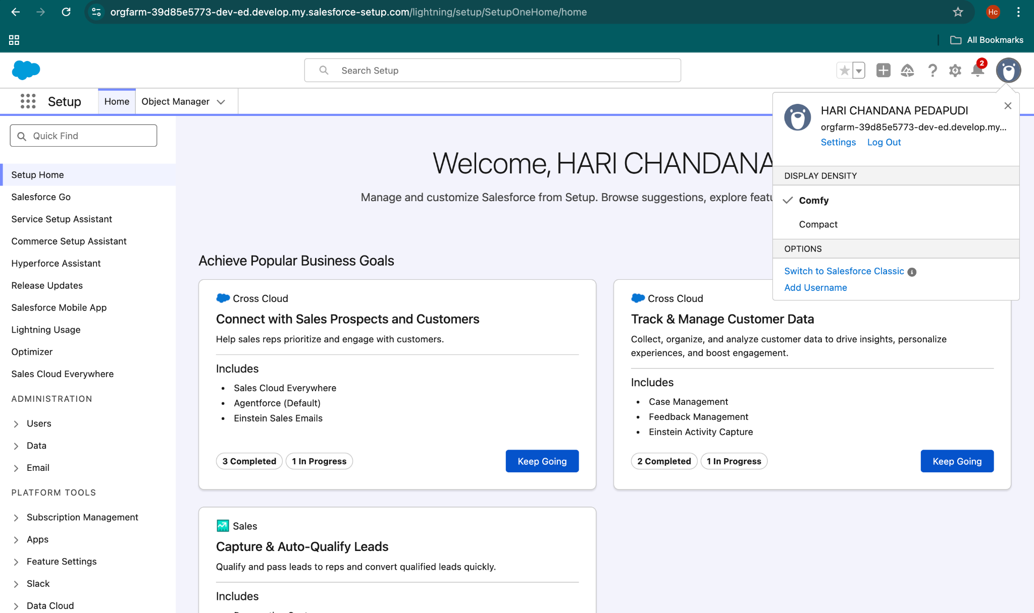

## 2. Company Profile Setup

Company Information is configured to define the organization name, locale, currency, and system preferences required for CRM operations.

### Configured Details (as per Developer Org)

* Organization Name: NA
* Organization Edition: Salesforce Developer Edition
* Default Language: English
* Default Locale: English (United States)
* Time Zone: (GMT‑08:00) Pacific Standard Time
* Currency Locale: USD

These settings confirm that the project is developed in a Salesforce Developer Org, which is suitable for academic and learning purposes.

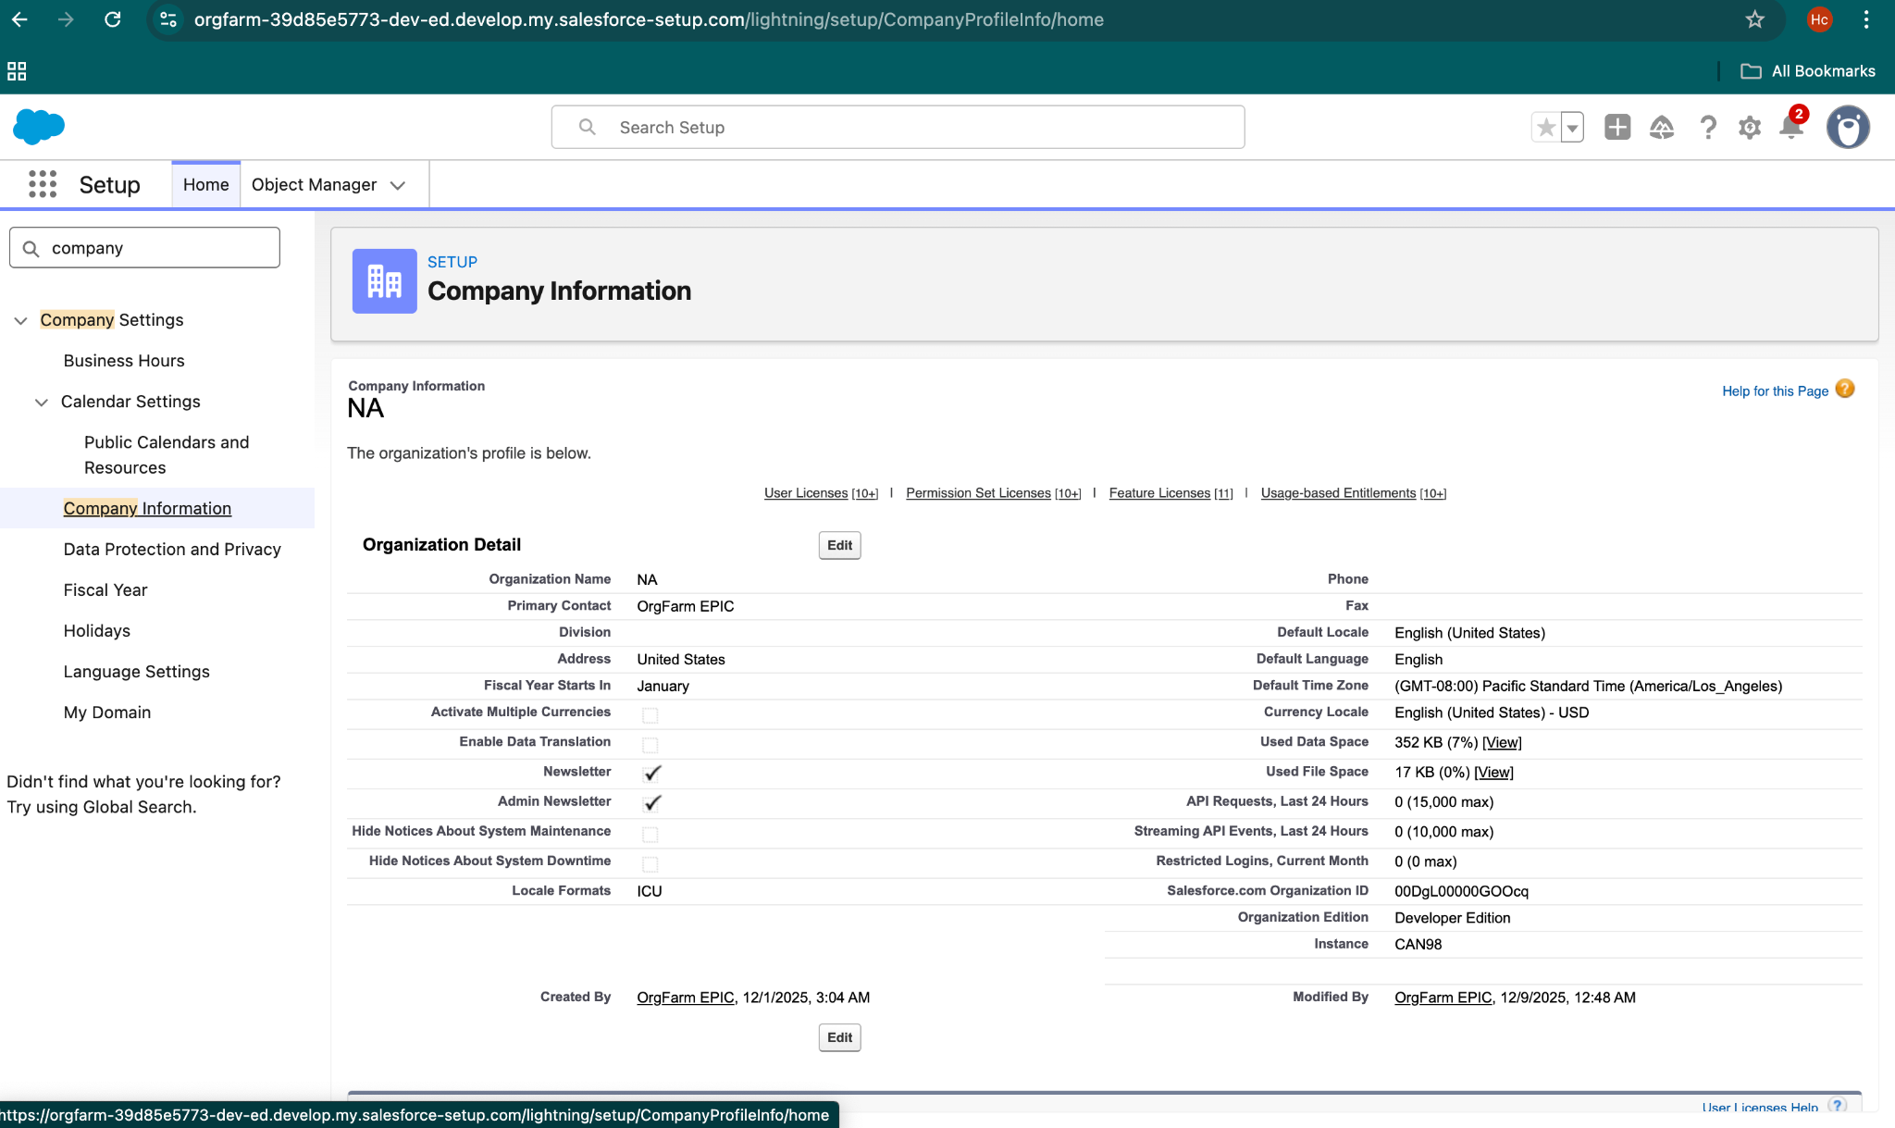

## 3. Business Hours & Holidays

### Use Case

Business Hours define the operational working schedule of the institution and can be used in approvals and future automations.

### Configured Values

* Business Hours: Monday – Friday, 9:00 AM to 5:00 PM
* Holidays: National holidays such as Republic Day, Independence Day, Diwali, and Christmas

## 4. Fiscal Year Settings

### Use Case

Fiscal Year settings align reporting and administrative processes with financial and academic standards followed in India.

### Configured Value

* Fiscal Year Type: Standard
* Duration: April – March

## 5. User Setup & Licenses

### Use Case

User setup defines who can access the CRM and what level of functionality they can use.

For this project, users are created to represent administrative and operational roles.

### Users Configured

* System Administrator – Full access
* Standard User – Limited access to records

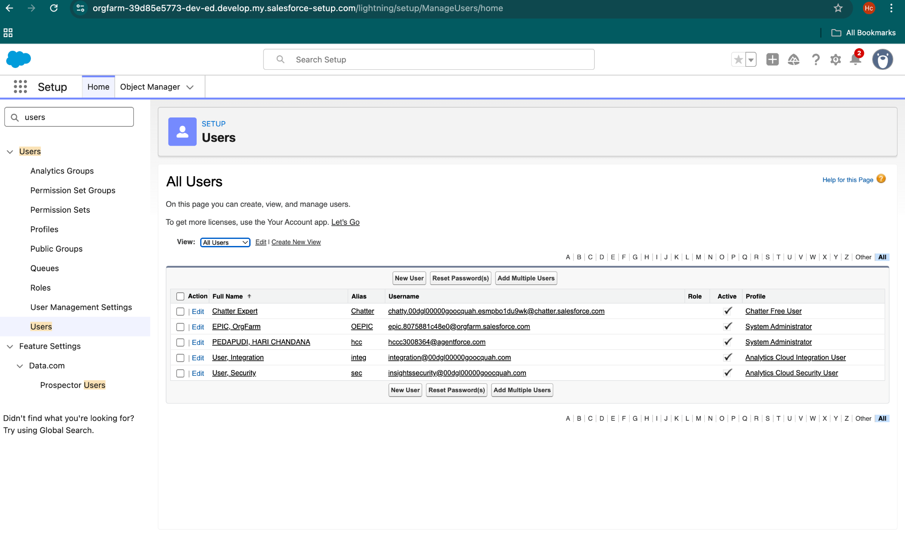

## 6. Login Access Policies

### Use Case

Login Access Policies help secure the CRM by controlling session behavior and access rules.

### Configured Settings

* Session Timeout: 30 minutes
* Login IP Relaxation: Enabled
* Multi‑Factor Authentication: Enabled for administrators

## 7. Developer Org Setup

### Use Case

The entire project is developed and tested in a Salesforce Developer Org, which provides a safe environment for learning and demonstration.

## 8. Sandbox Usage

### Use Case

In real‑world projects, sandboxes are used to test changes before deployment.  
For this academic project, sandbox usage is explained conceptually as future practice.

## 9. Deployment Basics

## Use Case

Deployment refers to moving configurations between environments using tools like Change Sets.

For this project, deployment is explained conceptually to demonstrate understanding of Salesforce release management.

# Phase 3: Data Modeling & Relationships

## Objective

The objective of this phase is to design and implement an efficient data model for the Campus Course Enrollment & Student Support CRM.  
This phase focuses on creating custom objects, defining fields, configuring layouts, and establishing appropriate relationships to support academic enrollment and certificate issuance processes.

## 1. Standard & Custom Objects

### Use Case

Standard Salesforce objects do not fully support academic enrollment and certification requirements. Therefore, custom objects are created to accurately represent the education domain.

### Custom Objects Implemented

* Student__c – Stores student details
* Course__c – Stores course information
* Enrollment__c – Represents student enrollment in courses
* Certificate_Request__c – Manages certificate issuance

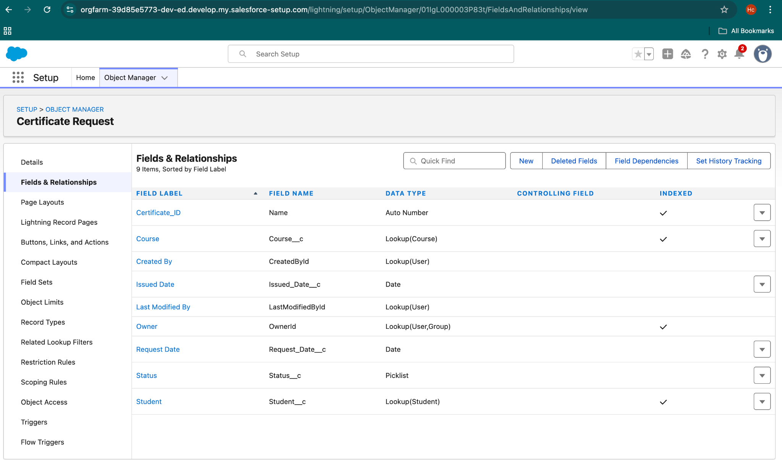

## 2. Fields

### Use Case

Fields store specific data required for academic tracking, automation, and reporting.

### Fields Implemented

Student Object

* Student ID (Auto Number)
* Student Name (Text)
* Email (Email)
* Department (Picklist)

Course Object

* Course ID (Auto Number)
* Course Name (Text)
* Department (Picklist)

Enrollment Object

* Student (Lookup)
* Course (Lookup)
* Status (Picklist: Enrolled, Completed)

Certificate Request Object

* Student (Lookup)
* Course (Lookup)
* Status (Picklist: Requested, Approved, Issued)

## 3. Record Types

### Use Case

Record Types are used when multiple business processes are required within the same object.

## 4. Page Layouts

### Use Case

Page Layouts control how fields are displayed on record pages, improving usability and data entry.

### Implementation in Project

Custom page layouts are configured for:

* Student
* Course
* Enrollment
* Certificate Request

## 5. Compact Layouts

### Use Case

Compact layouts define the key fields shown in the highlights panel of a record.

### Implementation in Project

Compact layouts are configured to display important information such as name and status.

## 6. Schema Builder

### Use Case

Schema Builder provides a visual view of objects and relationships, helping to understand the data model clearly.

### Implementation in Project

Schema Builder is used to visualize Student, Course, Enrollment, and Certificate Request objects and their relationships

## 7. Lookup vs Master‑Detail vs Hierarchical Relationships

### Use Case

Relationships define how objects are connected and how data behaves across records.

### Implementation in Project

* Lookup Relationships are used for flexibility and independent record management.

Relationships Used

* Enrollment → Student (Lookup)
* Enrollment → Course (Lookup)
* Certificate Request → Student (Lookup)
* Certificate Request → Course (Lookup)

Master‑Detail and Hierarchical relationships are not required for this business scenario.

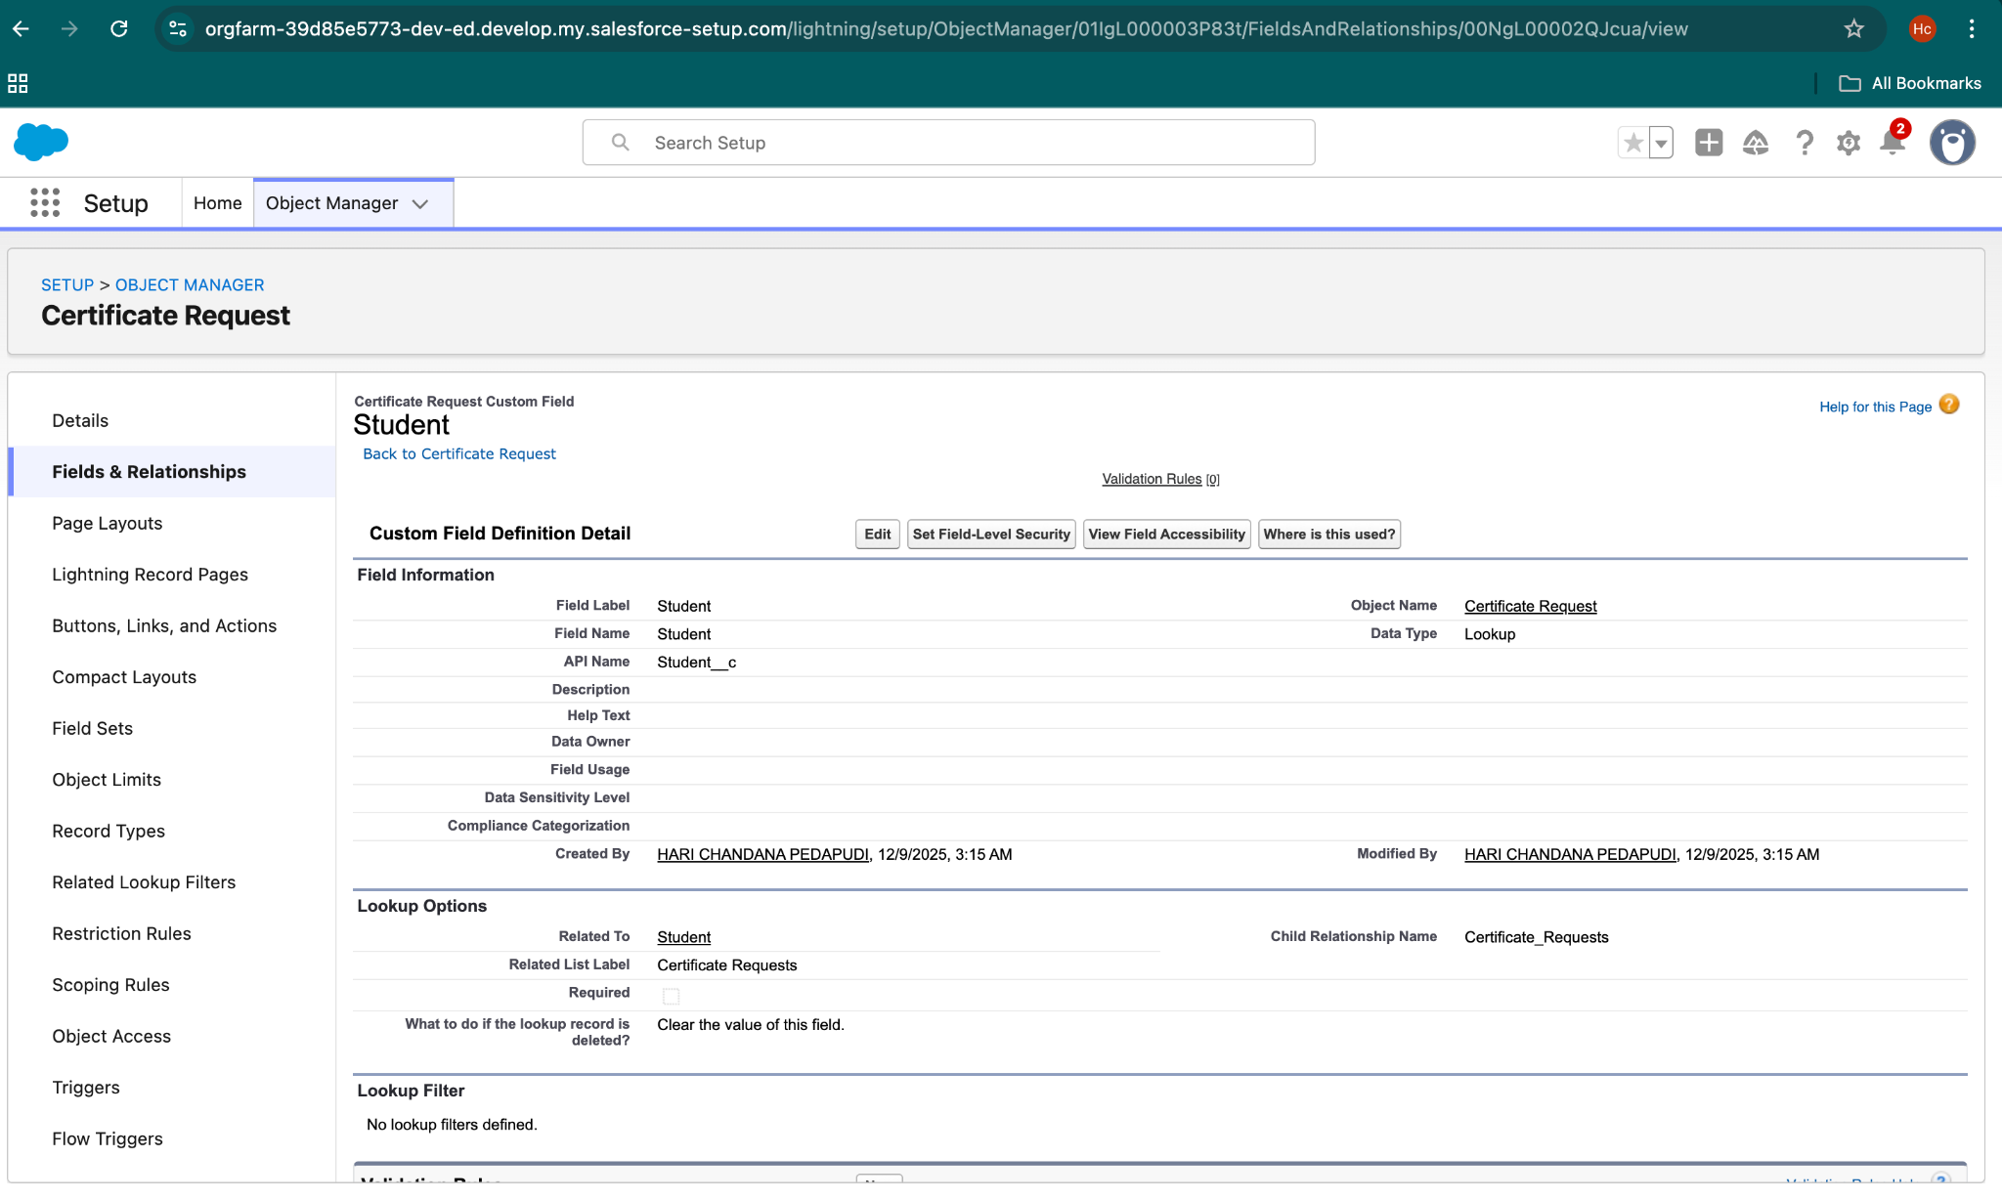

## 8. Junction Objects

### Use Case

Junction objects are used to manage many‑to‑many relationships.

### Implementation

The Enrollment object acts as a junction object between Student and Course.

## 9. External Objects

### Use Case

External Objects are used to access data from external systems.

# Phase 4: Process Automation (Admin)

## Objective

The objective of Phase 4 is to automate key academic processes in the Campus Course Enrollment and Student Support CRM using Salesforce administrative tools. Process automation helps reduce manual effort, ensures data accuracy, and improves overall system efficiency.

## Validation Rules

Purpose:  
Validation rules are used to prevent incorrect or incomplete data from being saved in Salesforce.

Implementation in Project:  
A validation rule is implemented on the Certificate Request object to ensure that a certificate request cannot be approved unless both Student and Course fields are filled.

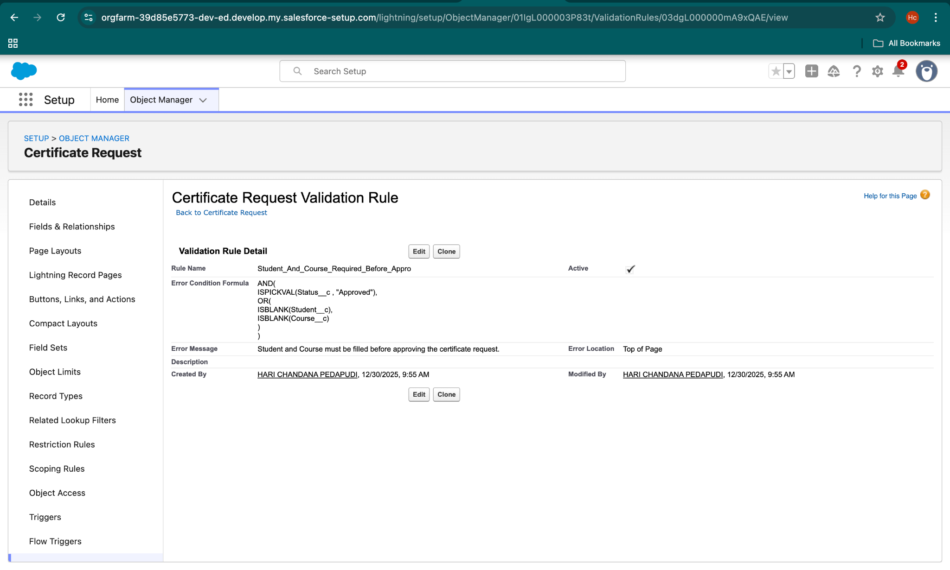

## Workflow Rules

Purpose:  
Workflow rules are used for simple automation such as field updates and email alerts.

Implementation in Project:  
Workflow rules are not implemented because Salesforce Flow Builder is used for automation. Flow Builder is more flexible and is the recommended Salesforce tool.

## Process Builder

Purpose:  
 Process Builder is used to automate business processes based on conditions.

Implementation in Project:  
 Process Builder is not implemented because all automation requirements are handled using Salesforce Flow Builder.

## Approval Process

Purpose:  
Approval processes are used when records require formal approvals.

Implementation in Project:  
A formal approval process is not configured. Certificate approval is managed using status changes and automation logic to keep the system simple.

## Flow Builder (Record‑Triggered Flows)

Purpose:  
Flow Builder is used to automate business processes based on record changes.

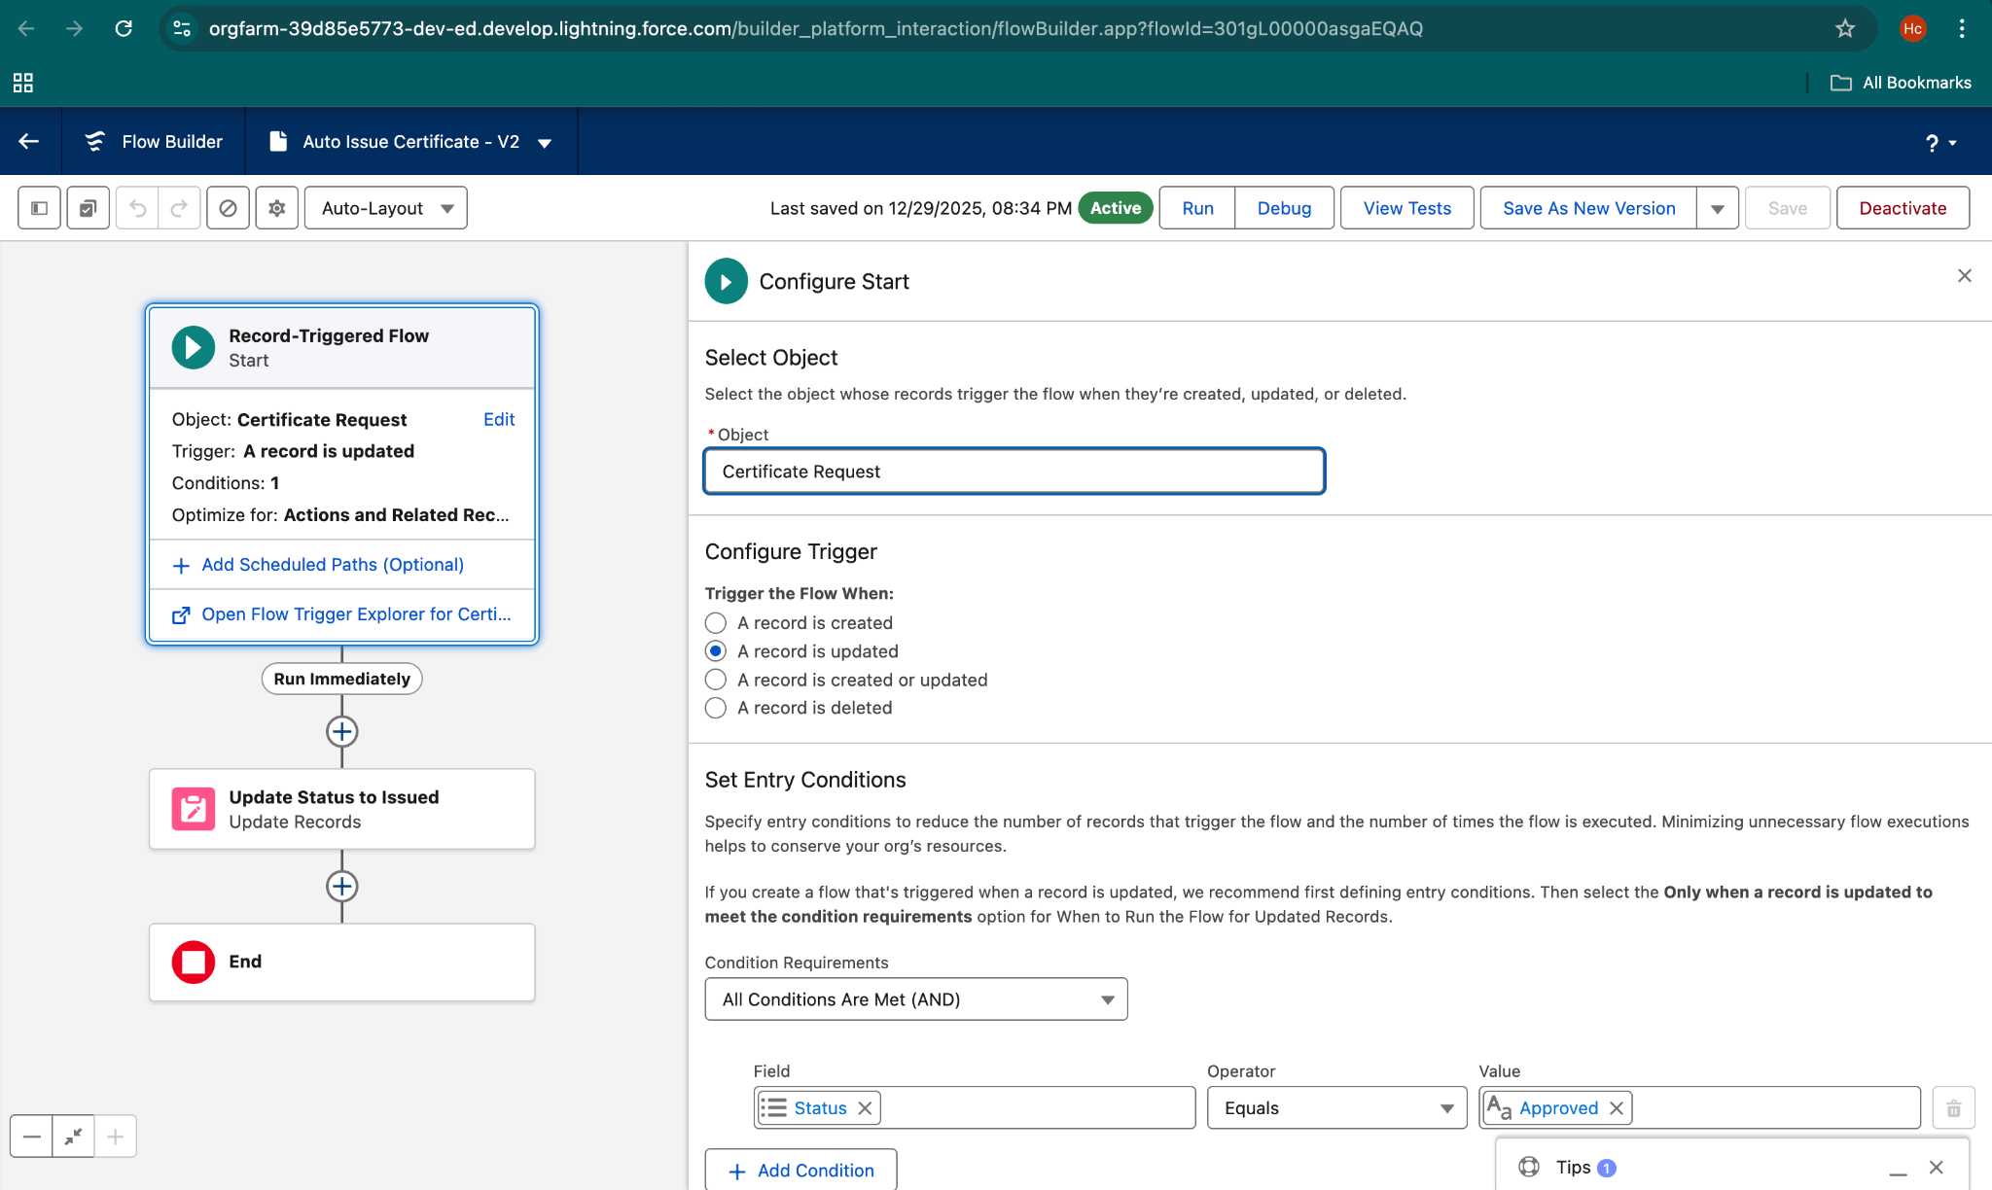

### Flow 1: Certificate Request Creation

Use Case:  
When a student completes a course, a certificate request should be created automatically.

Automation Logic:

* Object: Enrollment
* Trigger Condition: Status = Completed
* Action: Create Certificate Request record with status = Requested

### Flow 2: Certificate Issuance Automation

Use Case:  
When a certificate request is approved, the certificate should be issued automatically.

Automation Logic:

* Object: Certificate Request
* Trigger Condition: Status = Approved
* Action: Update status to Issued

## Screen Flows

Purpose:  
Screen flows guide users through step‑by‑step interactions.

Implementation in Project:  
Screen flows are not implemented because the automation is system‑driven and does not require user input.

## Scheduled Flows

Purpose:  
Scheduled flows run automation at a specific time.

Implementation in Project:  
Scheduled flows are not implemented because automation is triggered by record updates.

## Auto‑Launched Flows

Purpose:  
Auto‑launched flows run automatically in the background.

Implementation in Project:  
The record‑triggered flows implemented in this project function as auto‑launched flows.

## Email Alerts

Purpose:  
Email alerts notify users when specific events occur.

## Field Updates

Purpose:  
Field updates automatically update record values during automation.

Implementation in Project:  
Field updates are used within flows to update the Certificate Request status during the issuance process.

## Tasks

Purpose:  
Tasks are used to assign follow‑up actions.

Implementation in Project:  
Tasks are not implemented because automation handles all required actions.

## Custom Notifications

Purpose:  
Custom notifications inform users inside Salesforce.

# Phase 5: Apex Programming (Developer)

## Objective

The objective of Phase 5 is to implement server‑side business logic using Apex programming where declarative tools are not sufficient. This phase focuses on automation, data processing, and validation through Apex Classes, Apex Triggers, and Test Classes.

## Apex Classes

An Apex class named CertificateService is created. The class uses SOQL to fetch certificate request details based on record ID and includes exception handling to manage runtime errors.

### Key Concepts Covered

* Apex Class creation
* SOQL queries
* Exception handling

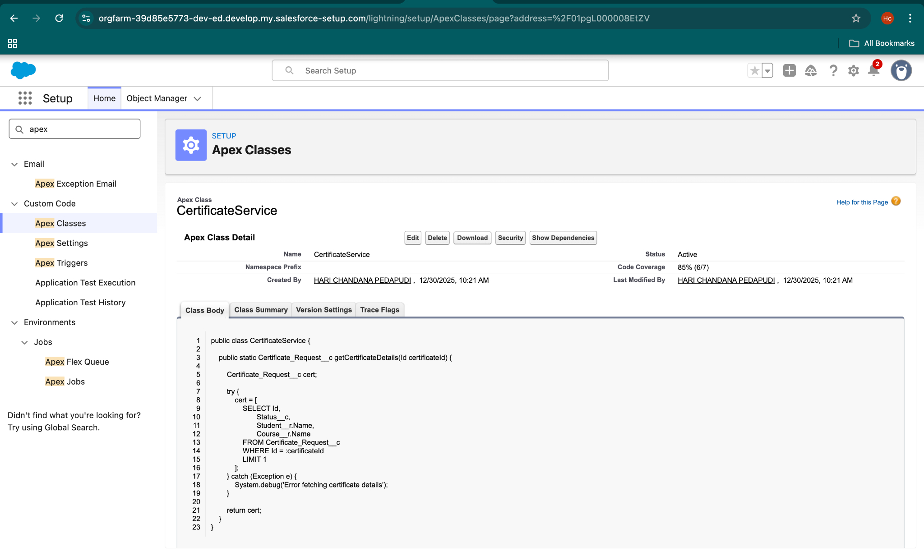

## Apex Triggers

## Use Case

To automate certificate issuance when a certificate request is approved, an Apex trigger is implemented. This ensures consistency and removes manual intervention.

### Implementation

A before update Apex trigger is created on the Certificate Request object. When the Status changes from Requested to Approved, the trigger automatically:

* Updates the Issued Date
* Changes the Status to Issued

### Why Before Update

Using a before update trigger allows modification of records without additional DML operations, avoiding read‑only and recursion issues.

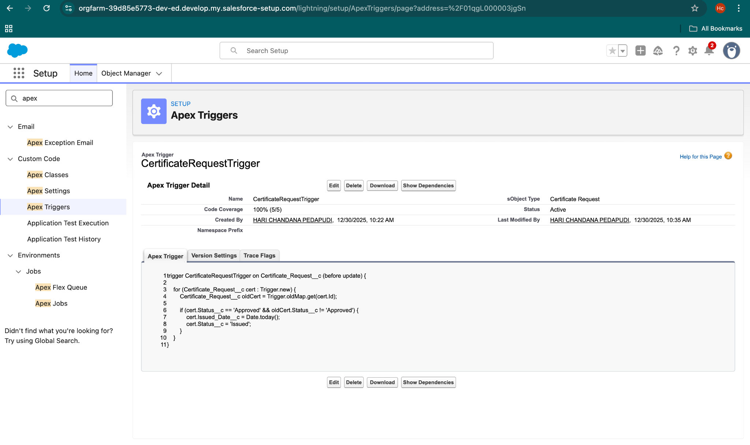

## Test Classes

### Use Case

Test classes are mandatory in Salesforce to validate Apex code and ensure correct functionality. They also help achieve required code coverage.

### Implementation

A test class named CertificateServiceTest is implemented. The test class:

* Creates a Certificate Request record
* Updates the Status to Approved
* Verifies that the trigger changes the Status to Issued
* Confirms the Apex class returns valid data

### Key Concepts Covered

* @isTest annotation
* Test data creation
* Assertions
* Trigger and class validation



## Result & Automation Outcome

* Certificate issuance process is fully automated
* Issued Date and Status are updated automatically
* Business logic is centralized and reusable
* Code coverage requirements are met



# Phase 6: UI Customization (User Experience)

## Objective

The objective of Phase 6 is to enhance the user interface and user experience of the Art Gallery / Certificate Management CRM by customizing page layouts, Lightning Record Pages, and compact layouts. This phase ensures that users can easily view, enter, and manage data efficiently.

## Page Layout Customization

### Use Case

Page Layouts are customized to control the fields, sections, and related lists displayed to users. This helps ensure that users see only relevant information based on business requirements.

### Implementation

The Certificate Request Page Layout is customized to:

* Display important fields such as Status, Student, Course, Request Date, and Issued Date
* Organize fields into logical sections
* Remove unnecessary standard fields

## Lightning Record Page Customization

### Use Case

Lightning Record Pages provide a dynamic and modern UI by using components such as highlights panel, tabs, and related lists. This improves usability and navigation.

### Implementation

A custom Lightning Record Page is configured for the Certificate Request object with:

* Highlights Panel showing key fields (Status, Issued Date)
* Tabs for Details and Related Lists
* Activity Timeline for tracking user actions

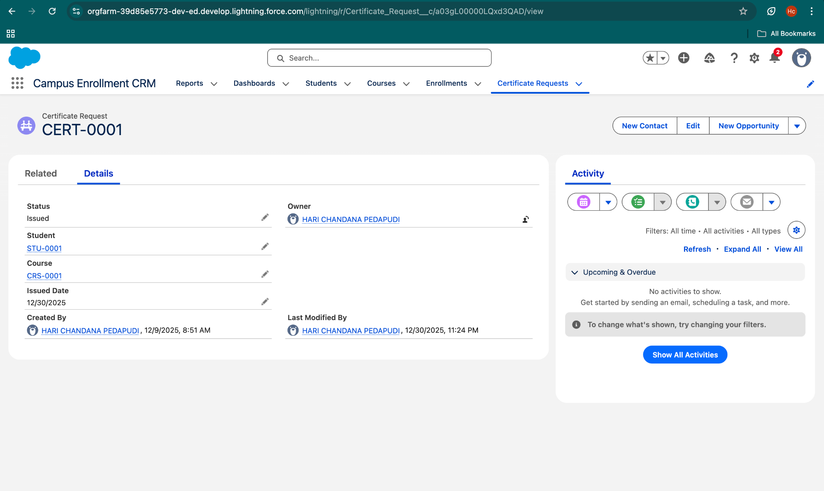

## Compact Layouts

### Use Case

Compact Layouts define which fields appear in the Highlights Panel at the top of a record. This allows users to quickly view critical information without scrolling.

### Implementation

A Compact Layout is created for Certificate Request to display:

* Certificate ID
* Status
* Issued Date

## Related Lists Customization

### Use Case

Related Lists help users view associated records directly from the parent record page.

### Implementation

Relevant related lists such as:

* Activities
* History Tracking

are enabled and arranged on the page layout for better visibility.

# Phase 7: Integration & External Access

## Objective

The objective of Phase 7 is to demonstrate Salesforce’s capability to integrate with external systems and services. This phase focuses on secure communication, API access, authentication, and external data connectivity using Salesforce integration features.

## Named Credentials

### Use Case

Named Credentials are used to securely store endpoint URLs and authentication details for external systems. They simplify callouts by removing hard‑coded credentials from Apex code.

### Implementation

In this project, a Named Credential is created to represent an external REST service endpoint. Authentication details are managed centrally to ensure security and easy maintenance.

## Remote Site Settings

### Use Case

Remote Site Settings allow Salesforce to make outbound callouts to external services securely.

### Implementation

A Remote Site Setting is configured with an external service URL to enable Apex callouts for integration testing.

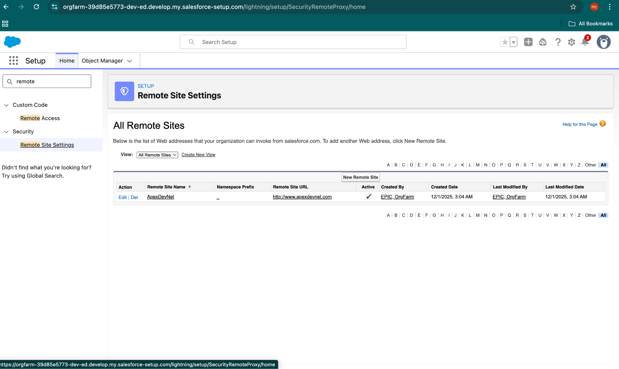

## Web Services (REST)

### Implementation

A REST‑based integration approach is used where Salesforce can consume external REST APIs. This enables data exchange between Salesforce and third‑party systems.

## Callouts

### Implementation

An Apex HTTP callout is implemented to fetch sample data from an external REST service. This demonstrates Salesforce’s outbound integration capability.

## OAuth & Authentication

### Implementation

OAuth authentication is configured through Named Credentials to securely authenticate external API access.

## API Limits

## Implementation

API usage is monitored using Salesforce System Overview to ensure integrations remain within permitted limits.

## External Services

### Implementation

External Services are explored to demonstrate low‑code integration capabilities. This enables Flow‑based integrations for future enhancements.

## Salesforce Connect

### Implementation

Salesforce Connect is studied and documented as a potential approach for real‑time external data access. It is not fully implemented due to project scope.

# Phase 8: Data Management & Deployment

## Objective

The objective of Phase 8 is to manage data efficiently within Salesforce and demonstrate deployment techniques used to move configurations between environments. This phase focuses on data import, data quality, backup, and deployment best practices.

## Data Import Wizard

### Use Case

Data Import Wizard is used to import small to medium volumes of data into Salesforce without writing code. It supports standard and custom objects.

### Implementation

In this project, Data Import Wizard is used to import sample data for objects such as:

* Student
* Course
* Certificate Request

## Data Loader

### Implementation

Data Loader is explored to understand bulk data operations. It is used to export Certificate Request records for backup and analysis purposes.

## Duplicate Rules

### Use Case

Duplicate Rules prevent the creation of duplicate records and maintain data quality.

### Implementation

A Duplicate Rule is configured for the Student object to prevent duplicate student records based on key fields such as Email or Student ID.

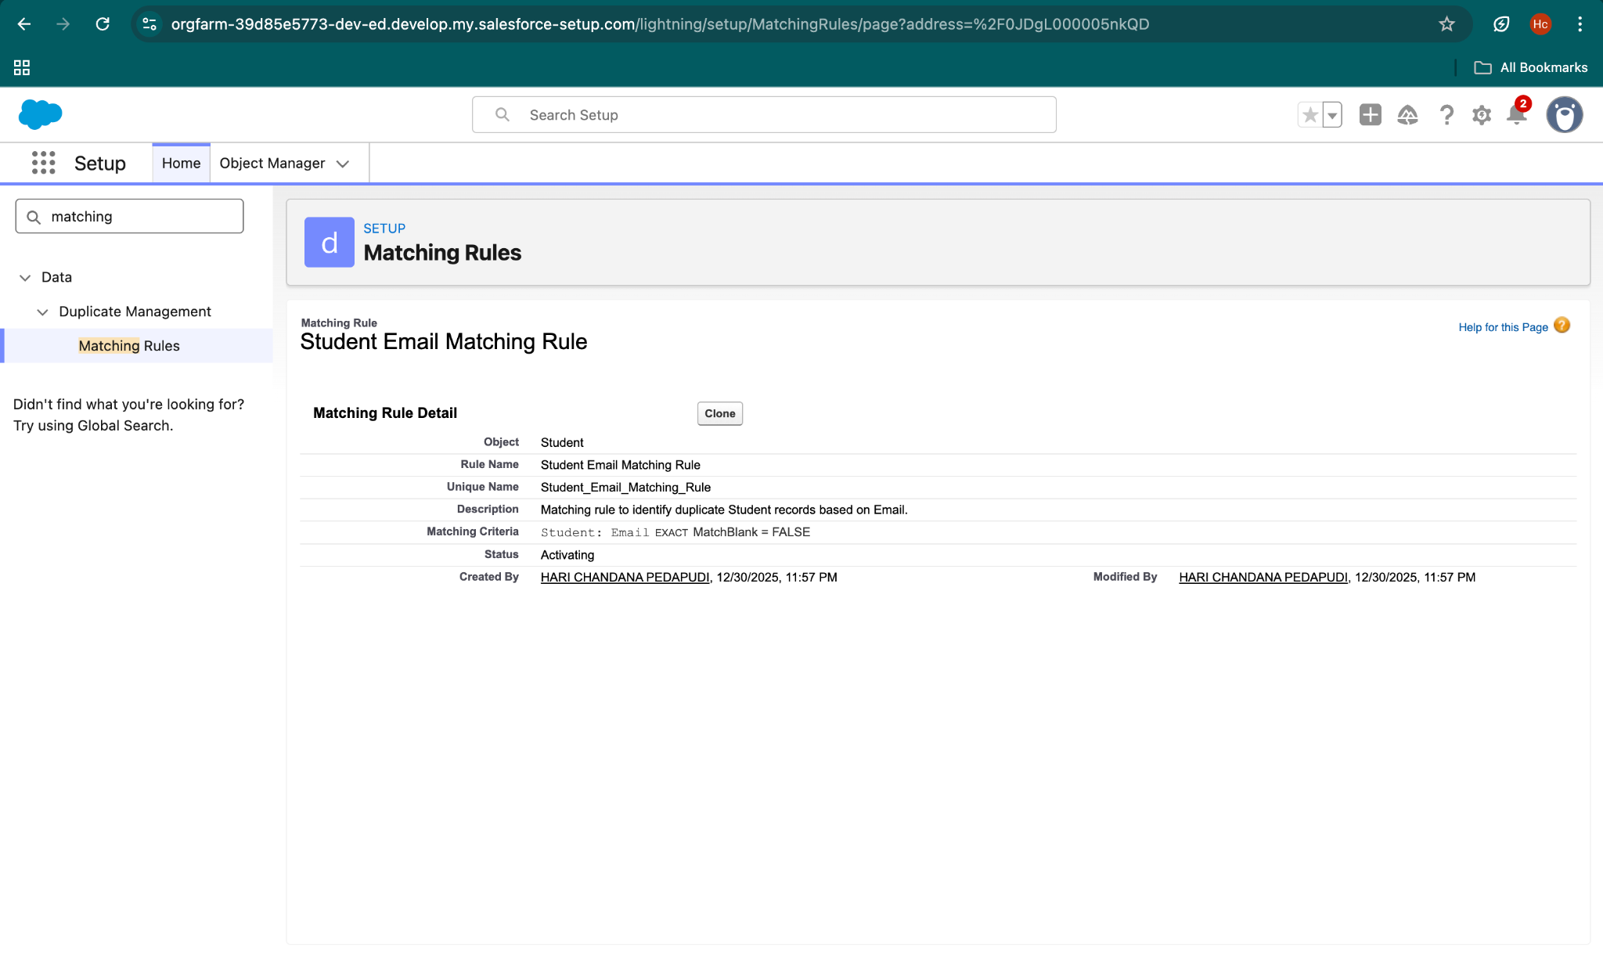

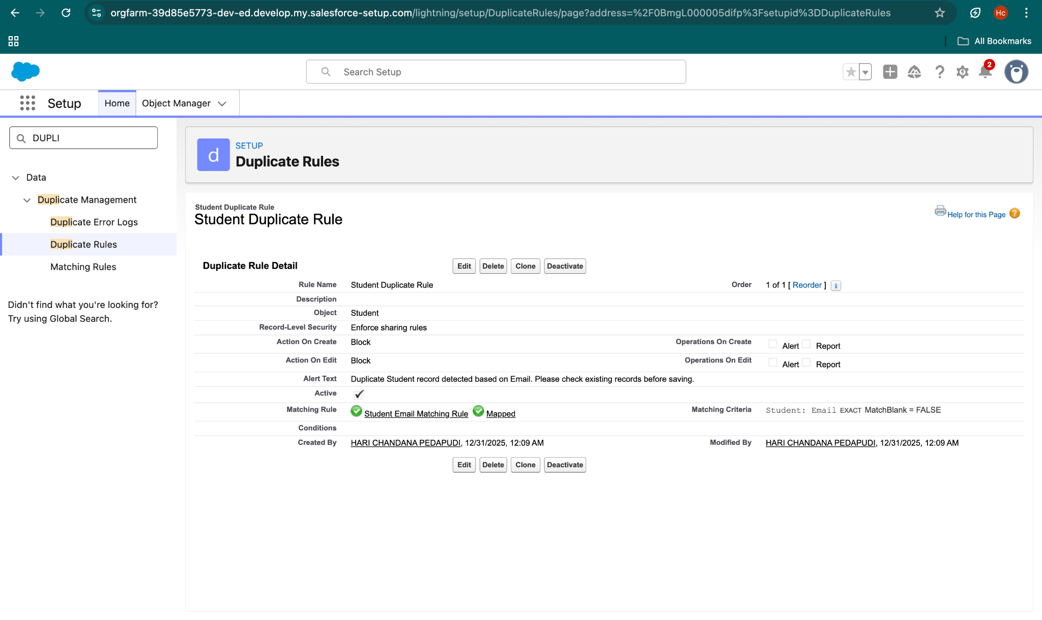

## Data Export & Backup

### Use Case

Data Export is used to create regular backups of Salesforce data to prevent data loss.

### Implementation

Salesforce Data Export is configured to export data periodically. Exported data includes Certificate Requests, Students, and Courses.

## Change Sets

### Use Case

Outbound and Inbound Change Sets are created to deploy:

* Custom objects
* Fields
* Apex classes
* Apex triggers

## Unmanaged vs Managed Packages

Unmanaged packages are studied and documented as they are suitable for internal project deployment and academic use. Managed packages are reviewed conceptually.

## ANT Migration Tool

ANT Migration Tool is explored as an alternative deployment option for large‑scale projects. It is documented for conceptual understanding.

## VS Code & Salesforce DX (SFDX)

VS Code and Salesforce DX are explored to understand project structure, metadata retrieval, and deployment workflows.

# Phase 9: Reporting, Dashboards & Security Review

## Objective

The objective of Phase 9 is to analyze project data using reports and dashboards and to review the security configuration implemented in the Salesforce CRM.

## Reports

### Tabular Report – Certificate Requests List

Use Case:  
To view all certificate request records in a simple list format.

What We Did:  
A tabular report is created on the Certificate Request object displaying fields such as Certificate ID, Student, Course, Status, and Issued Date.

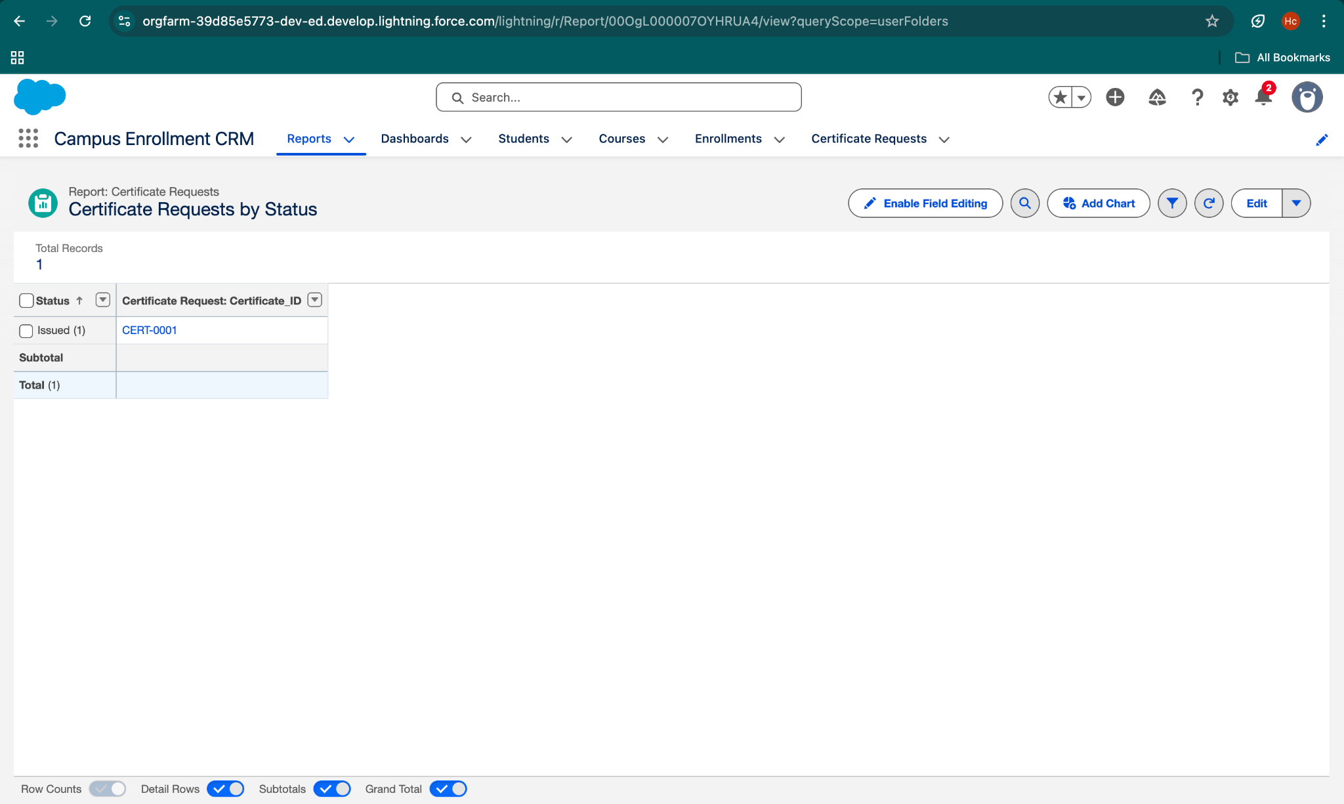

## Dashboards

### Dashboard – Certificate Management Overview

Use Case:  
To get a quick visual overview of certificate processing and request status.

What We Did:  
A dashboard is created using the above reports with chart components to visually represent certificate request data.

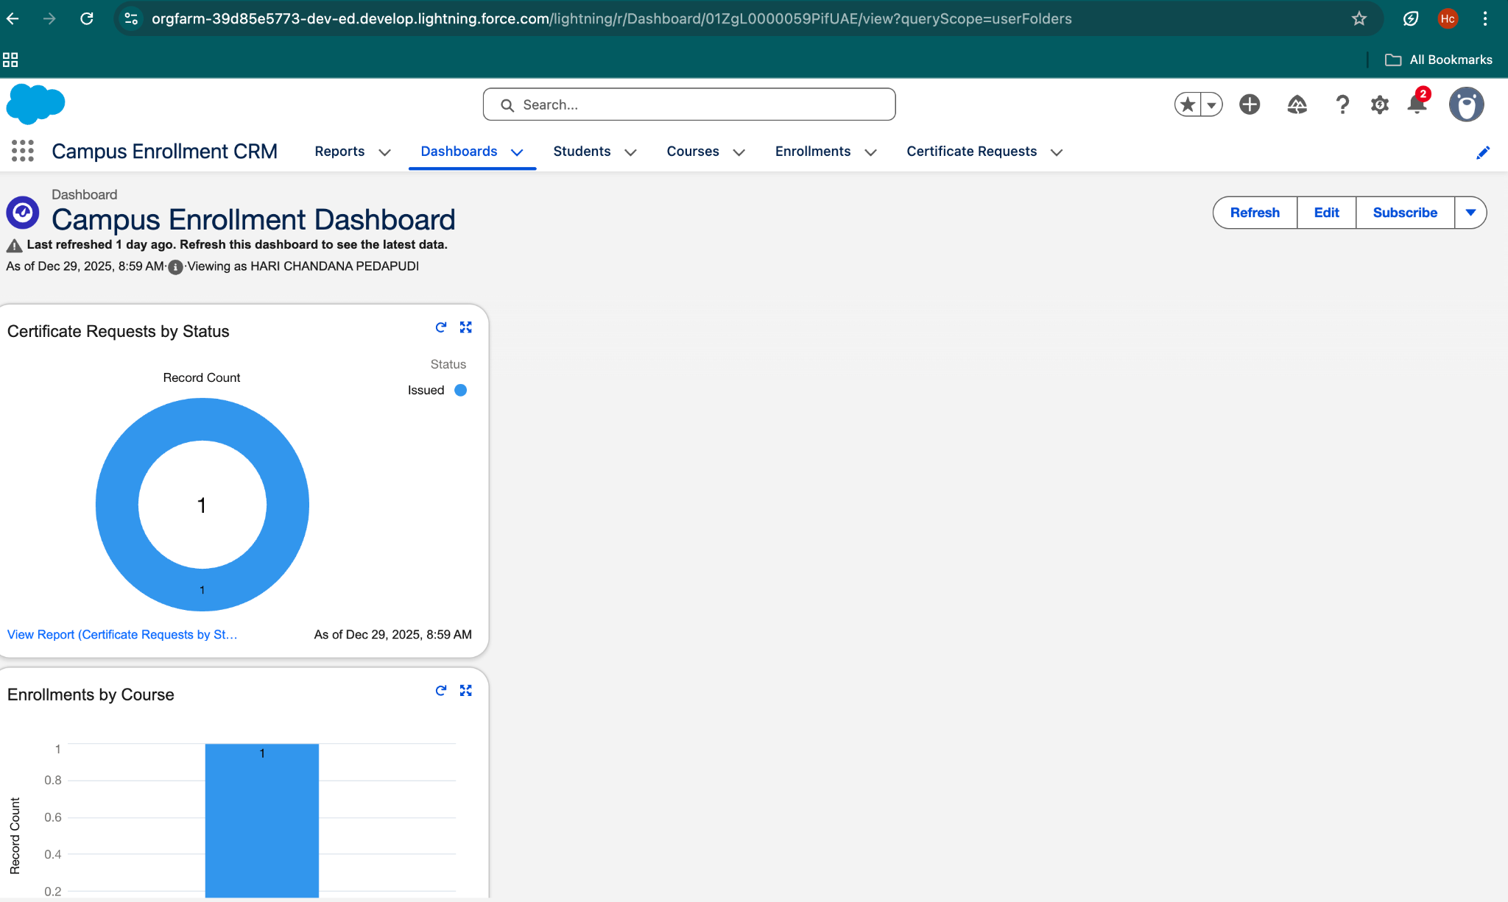

## Profiles

Use Case:  
To control what users can access and modify in the system.

What We Did:  
Profiles are used to manage permissions for Admin and Standard User roles.

## Roles

Use Case:  
To manage record visibility using role hierarchy.

What We Did:  
Roles are configured to control data visibility across users.

## Users

Use Case:  
To allow users to access the Salesforce application.

What We Did:  
Users are created and assigned appropriate profiles and roles.

## Permission Sets

Use Case:  
To grant additional permissions without changing user profiles.

What We Did:  
Permission sets are created and assigned to users based on requirements.

## Organization‑Wide Defaults (OWD)

Use Case:  
To define default access to records.

What We Did:  
OWD settings are configured to control default visibility for Certificate Request records.

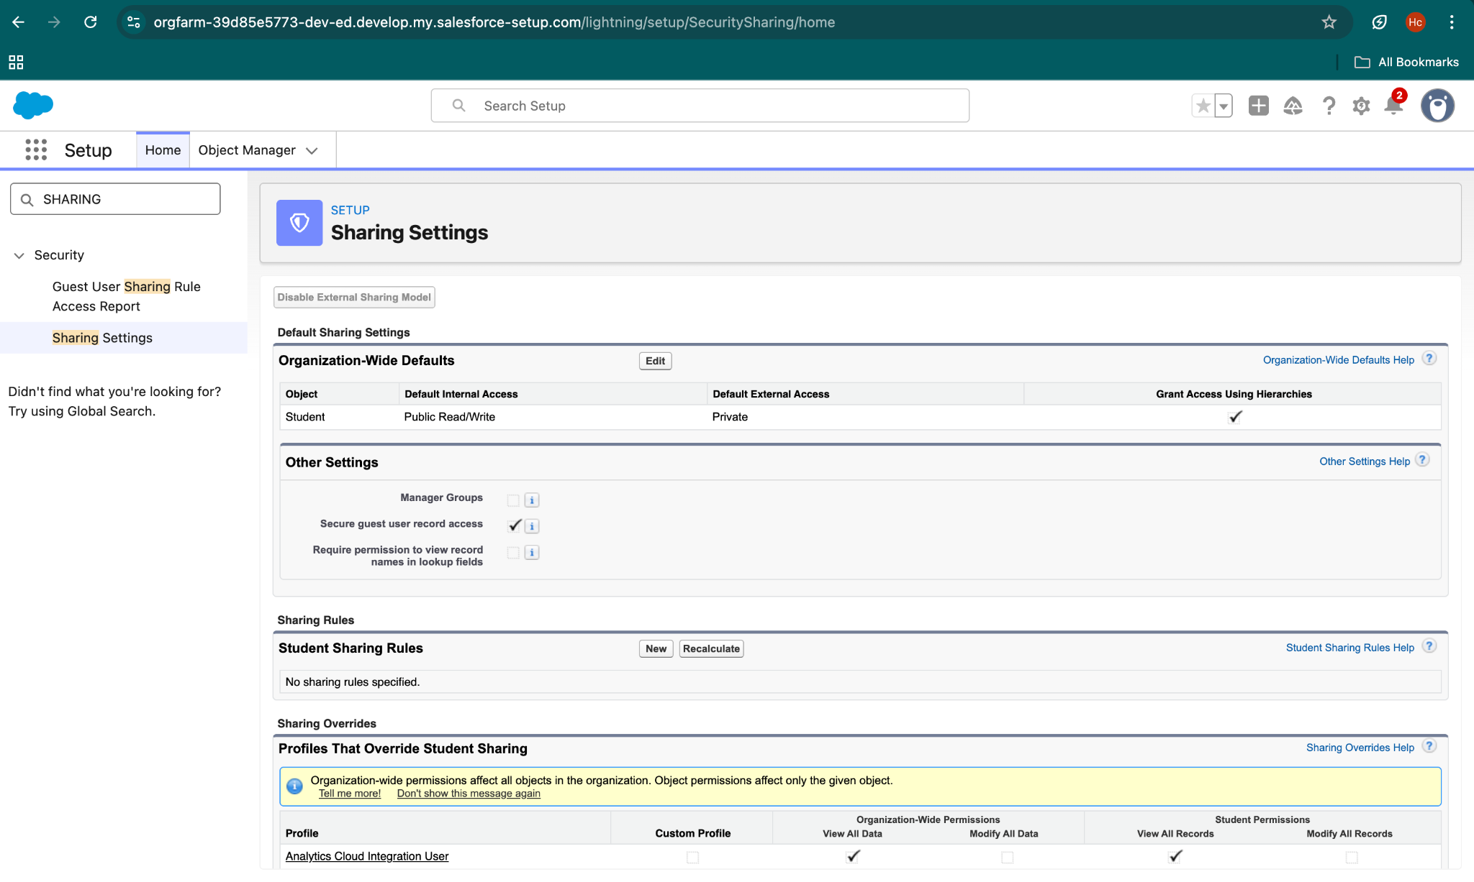

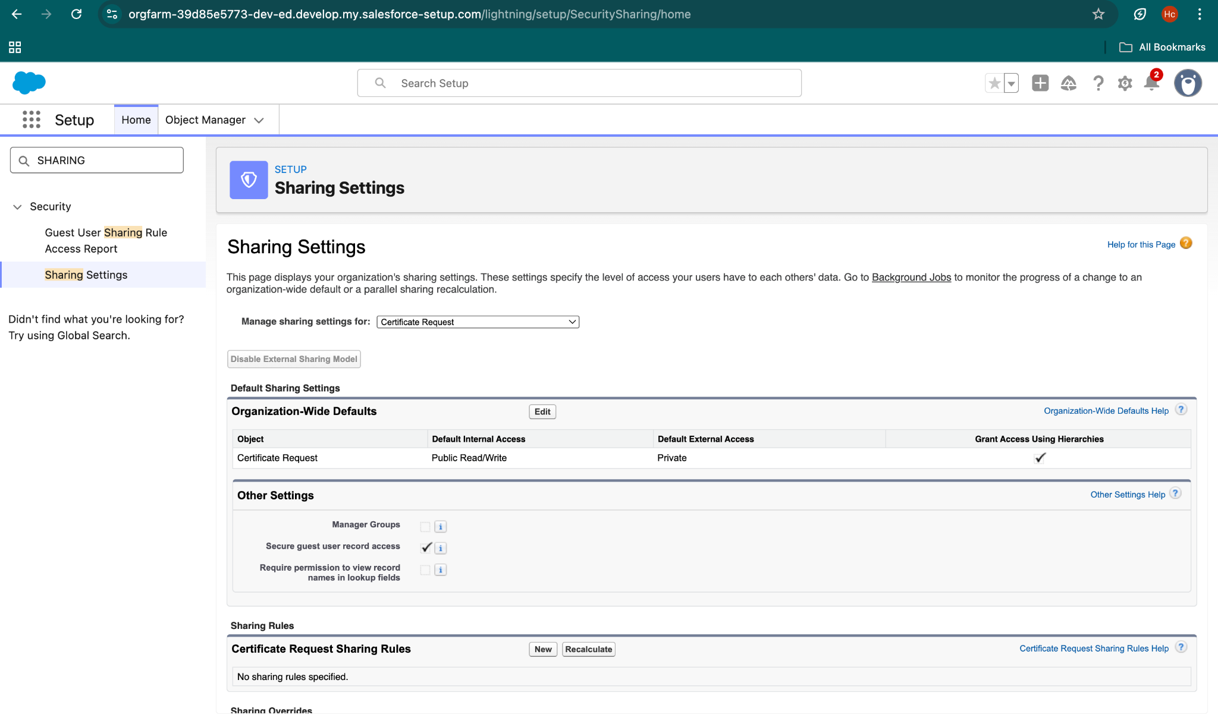

## Sharing Rules

Use Case:  
To share records with specific users or roles.

What We Did:  
Sharing rules are created for the Certificate Request object to extend record access.

## Field‑Level Security

Use Case:  
To restrict access to sensitive fields.

What We Did:  
Field‑level security is applied to hide selected fields from standard users.

## Session Settings

Use Case:  
To improve login and session security.

What We Did:  
Session timeout and related security settings are configured.

## Audit Trail

Use Case:  
To track administrative changes made in the system.

What We Did:  
Audit Trail is reviewed to monitor setup and configuration changes.

# Phase 10: Quality Assurance Testing

## Objective

The objective of Phase 10 is to validate that all implemented Salesforce features work as expected. Testing ensures data accuracy, automation correctness, and system reliability.

## Test Case 1: Certificate Request Record Creation

### Use Case / Scenario

Verify that a Certificate Request record can be created successfully.

### Test Steps (Input)

1. Navigate to Certificate Request tab
2. Click New
3. Enter Student, Course, and Status = Requested
4. Click Save

### Result

Certificate Request record is created successfully.

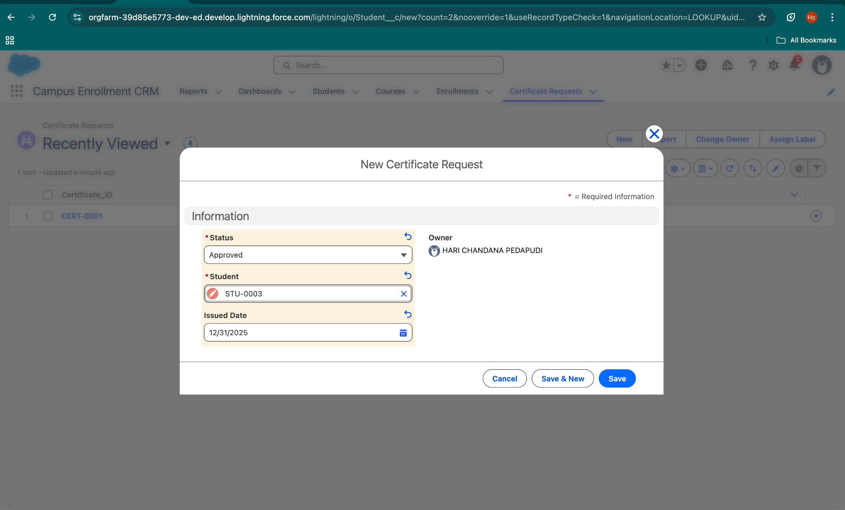

## Test Case 2: Validation Rule Testing

### Use Case / Scenario

Ensure validation rule prevents saving incomplete Certificate Request.

### Test Steps (Input)

1. Click New Certificate Request
2. Leave required fields empty
3. Click Save

### Result

Validation error message is displayed and record is not saved.

## Test Case 3: Apex Trigger – Certificate Issuance Automation

### Use Case / Scenario

Verify that certificate is automatically issued when status is Approved.

### Test Steps (Input)

1. Open an existing Certificate Request record
2. Change Status from Requested to Approved
3. Click Save

### Result

Status changed to Issued and Issued Date is auto‑filled.

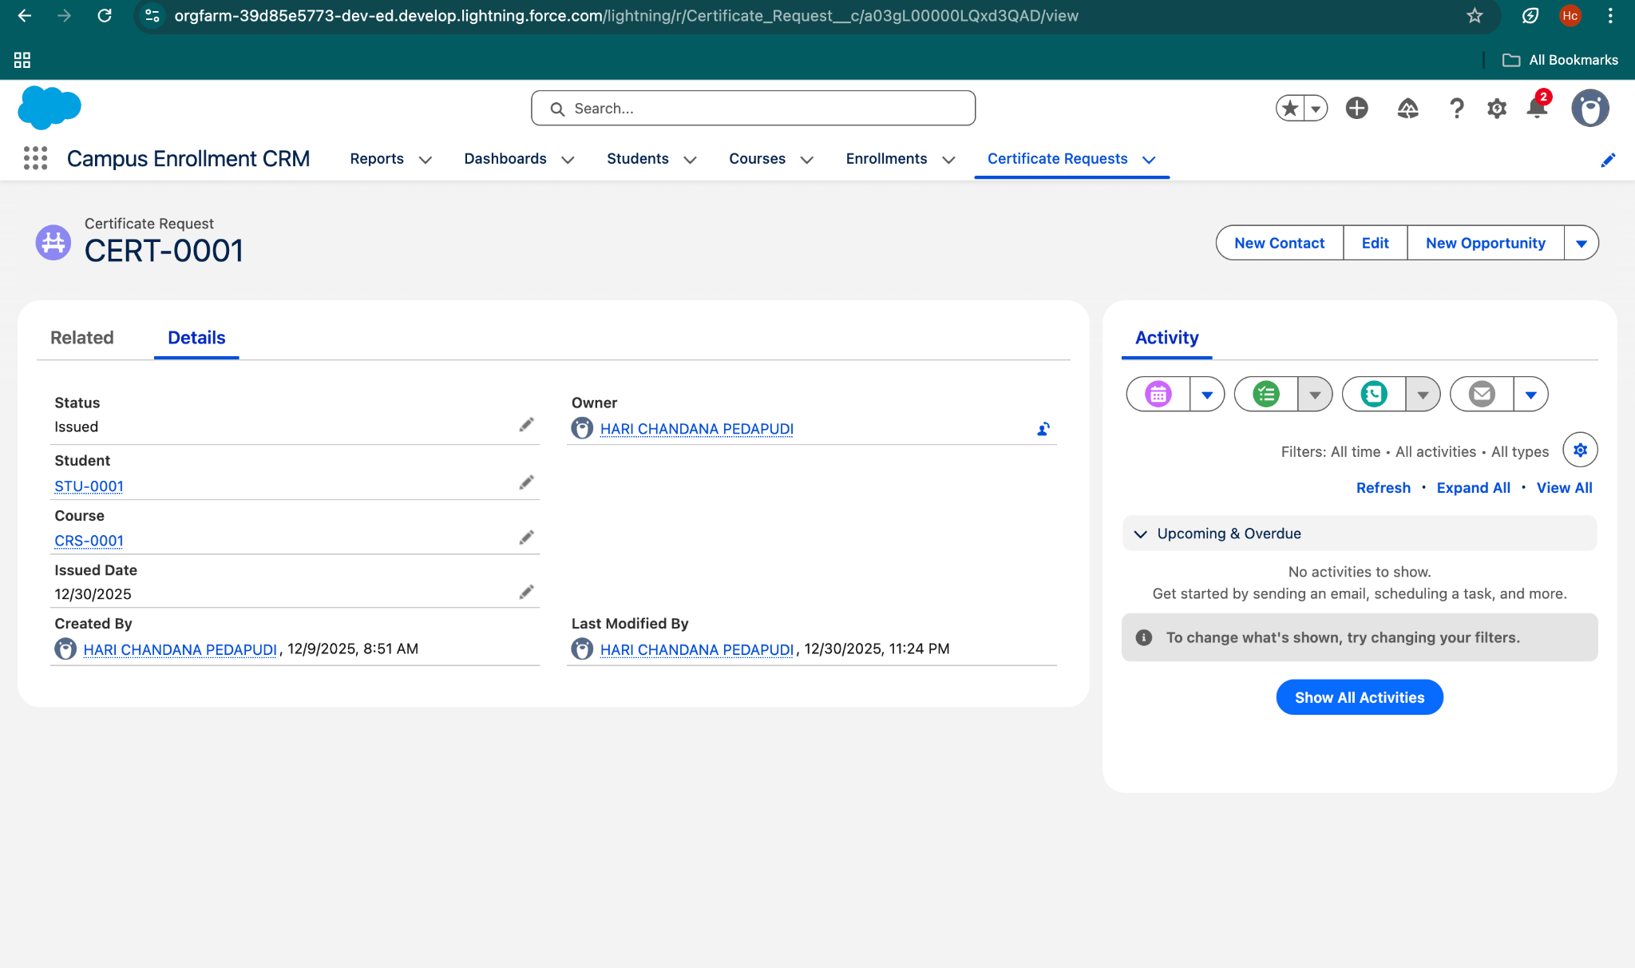

## Test Case 4: Flow Automation Testing

### Use Case / Scenario

Verify that record‑triggered flow executes correctly.

### Test Steps (Input)

1. Update Certificate Request status
2. Save the record

### Result

Flow executed successfully and record updated.

## Test Case 5: Report Generation Testing

### Use Case / Scenario

Verify that reports display correct data.

### Test Steps (Input)

1. Open Reports tab
2. Run Certificate Requests by Status report

### Result

Report displays correct grouped data.

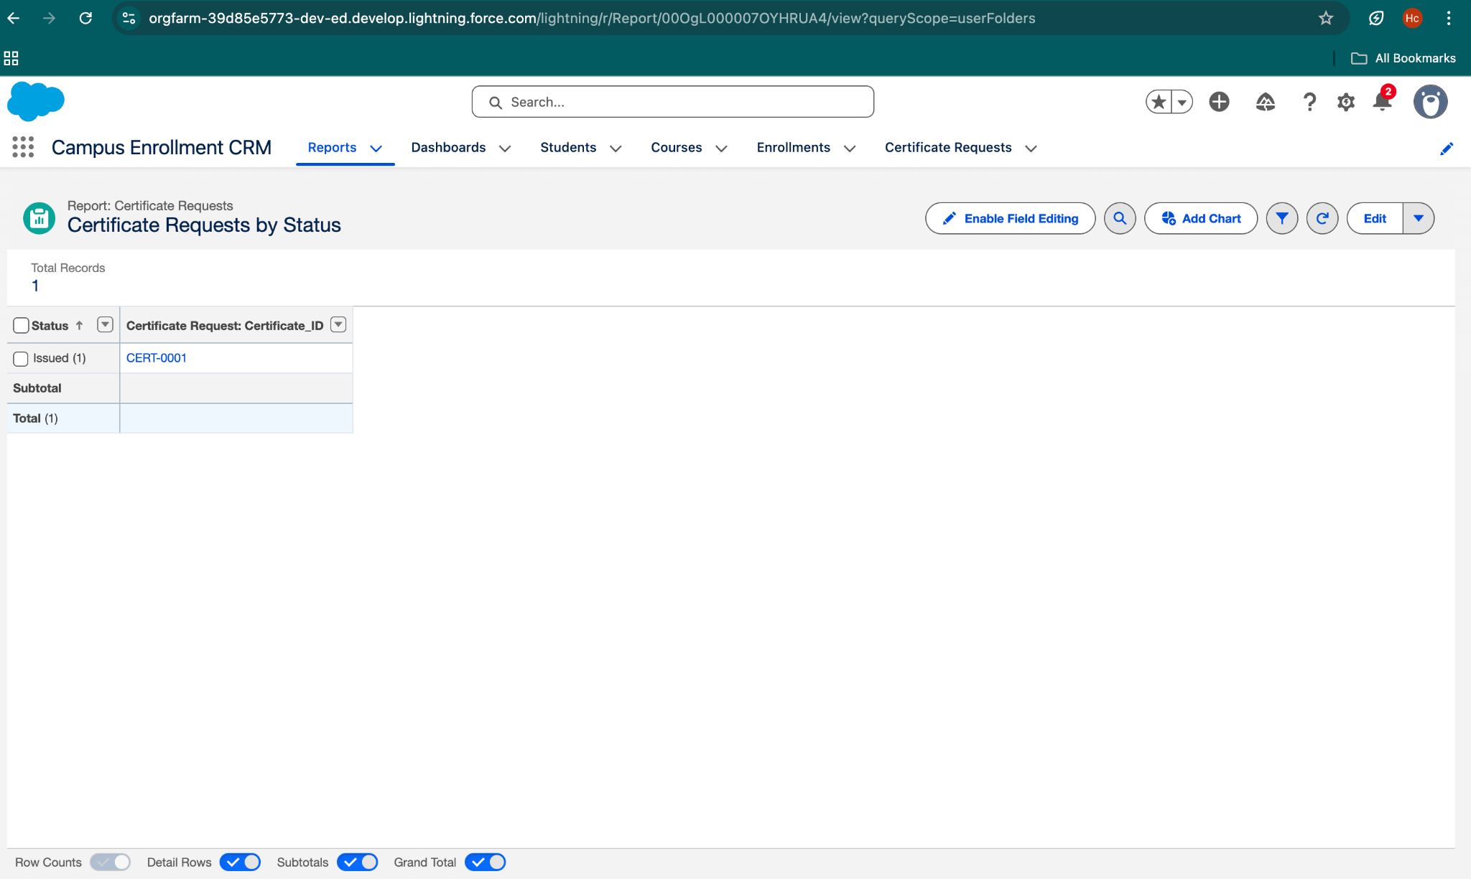

## Test Case 6: Dashboard Testing

### Use Case / Scenario

Verify that dashboard displays report data correctly.

### Test Steps (Input)

1. Open Dashboard
2. Refresh dashboard

### Result

Dashboard displays updated charts correctly.

